create table room_master(

room_number int primary key,

room_type varchar2(50),

room_description varchar2(50),

room_charge number

)

insert into room_master values (101,'gen','generalroom',450)

insert into room_master values (102,'gen','generalroom',450)

insert into room_master values (201,'sem','semi_delux',950)

insert into room_master values (202,'sem','semi_delux',950)

insert into room_master values (301,'del','delux',1500)

insert into room_master values (302,'del','delux',1500)

insert into room_master values (401,'icu','intensive care unit',3500)

insert into room_master values (402,'icu','intensive care unit',3500)

create table billing_master(

cons_id int primary key,

billing_month number,

cons_type varchar2(50),

last_reading number,

current_reading number,

total_unit number,

electricity_charge number

)

insert into billing_master values(10001,1202,'reg',1200,1505,0,0)

insert into billing_master values(10002,1202,'reg',800,1479,0,0)

insert into billing_master values(10003,1202,'reg',2800,3245,0,0)

insert into billing_master values(20001,1202,'htc',4500,5134,0,0)

insert into billing_master values(20002,1202,'htc',5000,5545,0,0)

insert into billing_master values(20003,1202,'htc',1200,4578,0,0)

insert into billing_master values(30001,1202,'com',2200,2567,0,0)

insert into billing_master values(30002,1202,'com',2500,3323,0,0)

insert into billing_master values(30003,1202,'com',1200,3400,0,0)

ASSIGNMENT-6

create table flight_master(

flightid int primary key,

flight_from varchar(50),

flight_to varchar(50),

dep_time varchar(50),

arr_time varchar(50),

freight int);

insert into flight_master values(10001,'baroda','bombay','07:30 am','06:00 am',4500);

insert into flight_master values(10002,'baroda','delhi','10:30 am','09:00 am',7500);

insert into flight_master values(10003,'baroda','calcutta','07:30 pm','05:00 pm',7500);

insert into flight_master values(10004,'baroda','amritsar','04:45 pm','03:00 pm',4500);

insert into flight_master values(10005,'baroda','bombay','08:45 pm','07:00 pm',4500);

insert into flight_master values(10006,'baroda','calcutta','08:30 pm','07:15 pm',7500

create table fee_master(

student_standard int primary key,

term_fee int,

library_fee int,

development_fee int,

computer_fee int,

sport_fee int);

insert into fee_master values(1,450,120,230,800,80);

insert into fee_master values(2,550,220,330,1100,370);

insert into fee_master values(3,750,390,470,1500,410);

insert into fee_master values(4,880,560,520,2300,500);

insert into fee_master values(5,950,660,680,2500,680);

STOCK

CREATE TABLE STOCK

(

CARTON_NO INT PRIMARY KEY,

CARTON_TYPE NUMBER,

YARN_TYPE VARCHAR2(255),

SHADE_CODE VARCHAR2(255),

COPS_TYPE VARCHAR2(255),

PKG_DATE DATE,

GROSS_WEIGHT NUMBER,

NET_WEIGHT NUMBER

);

INSERT INTO STOCK VALUES(10001,1,'POY',101,1,'23-DEC-02',220.5,0);

INSERT INTO STOCK VALUES(10002,1,'PFY',102,2,'23-DEC-02',250.79,0);

INSERT INTO STOCK VALUES(10003,1,'LOY',103,3,'23-DEC-02',350.79,0);

INSERT INTO STOCK VALUES(10004,2,'POY',101,1,'24-DEC-02',150.24,0);

INSERT INTO STOCK VALUES(10005,2,'PFY,102,2,'24-DEC-02',180.25,0);

INSERT INTO STOCK VALUES(10006,2,'LOY',103,3,'24-DEC-02',140.775,0);

INSERT INTO STOCK VALUES(10007,3,'PFY',101,1,'25-DEC-02',340.55,0);

INSERT INTO STOCK VALUES(10008,3,'POY',102,2,'25-DEC-02',350.25,0);

INSERT INTO STOCK VALUES(10009,3,'LOY',103,3,'25-DEC-02',370.35,0);

INSERT INTO STOCK VALUES(10010,3,'LOY',102,1,'26-DEC-02',350.435,0);

INSERT INTO STOCK VALUES(10011,2,'POY',103,3,'26-DEC-02',220.238,0);

INSERT INTO STOCK VALUES(10012,1,'LOY',101,2,'27-DEC-02',120.268,0);

INSERT INTO STOCK VALUES(10013,2,'POY',103,3,'27-DEC-02',150.735,0);

INSERT INTO STOCK VALUES(10014,1,'PFY',103,1,'27-DEC-02',280.15,0);

CREATE TABLE PASSENGER_DETAILS

(

PASSENGER_ID INT PRIMARY KEY,

FLIGHT_DATE DATE,

FLIGHT_ID NUMBER,

PASSENGER_NAME VARCHAR2(255),

ADDRESS VARCHAR2(255),

PINCODE_NO NUMBER,

NO_OF_PASSENGERS NUMBER,

EXTRA_CHARGES NUMBER

);

INSERT INTO PASSENGER_DETAILS VALUES(20001,'05-JAN-03',10001','A.B.TIVARI','ABC STREET BARODA',345245,31,0)

INSERT INTO PASSENGER_DETAILS VALUES(20003,'09-JAN-03',10002,'C.D.PATIL','CDE STREET BARODA',3455234,31,0)

INSERT INTO PASSENGER_DETAILS VALUES(20004,'09-JAN-03',10003,'A.D.PATIL','CDE STREET BARODA',3444234,10,0)

INSERT INTO PASSENGER_DETAILS VALUES(20005,'09-JAN-03',10003,'D.B.PATIL','CDE STREET BARODA',3477234,32,0)

INSERT INTO PASSENGER_DETAILS VALUES(20007,'09-JAN-03',10001,'E.F.DEOL','EFD STREET BARODA',342737,11,0)

INSERT INTO PASSENGER_DETAILS VALUES(20006,'10-JAN-03',10002,'F.G.DEOL','FGH STREET BARODA',3642435,45,0)

USING AGGREGATE FUNCTIONS

SELECT SUM(gross_weight) FROM stock;

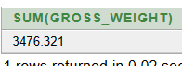

SELECT AVG(room_charge)FROM room_master;



SELECT MAX(current_reading), MIN(current_reading), AVG(last_reading) FROM billing_master;



SELECT SUM(gross_weight),COUNT(carton_no)FROM stock WHERE yarn_type = 'POY';



SELECT AVG(room_charge) FROM room_master WHERE room_type in ('GEN','DEL');



SELECT MAX(current_reading), MIN(current_reading),AVG(last_reading)FROM billing_master WHERE cons_type = 'REG';

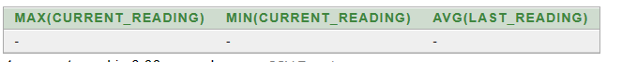

GROUP BY:

SELECT carton_type, AVG(net_weight),SUM(gross_weight)FROM stock GROUP BY carton_type;

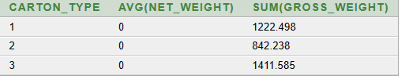

SELECT yarn_type,MAX(net_weight),MIN(gross_weight)FROM stock GROUP BY yarn_type;

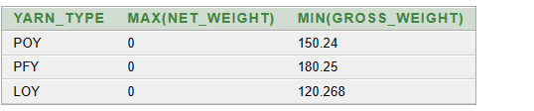

SELECT room_type,AVG(room_charge)FROM room_master GROUP BY room_type;

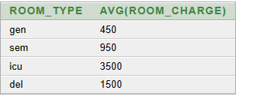

SELECT cons_type,MAX(current_reading),MIN(current_reading),AVG(last_reading)FROM billing_master GROUP BY cons_type;

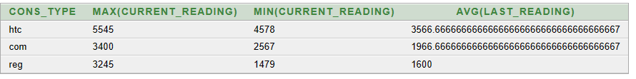

SELECT TO_CHAR(pkg_date,'DD'),COUNT(carton_no),SUM(gross_weight) FROM stock GROUP BY TO_CHAR(pkg_date,'DD');

EXERCISE:

Display packing month and yarn_type wise total gross_weight from stock table.

select pkg_date , sum(gross_weight) from stock group by yarn_type

Display room description wise total room_charge from room_master table.

select room_description, SUM(room_charge) from room_master group by room_description

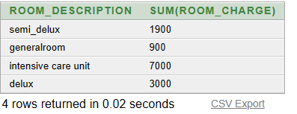

Display billing_month and cons_type wise total unit(current_reading - last_reading) from billing_information table.

select billing_month , SUM(total_unit) from billing_master group by cons_type

Display cons_type wise total no. of consumers from billing_information.

select cons_type, count(cons_id) from billing_master group by cons_type

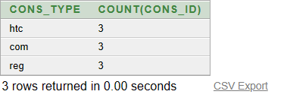

Display cops_type wise total no. of cartons from stock table.

select cops_type, sum(carton_no) from stock group by cops_type

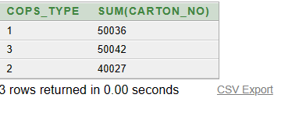

Display freight wise total no. of flights from flight_master.

select freight , sum(flightid) from flight_master group by freight

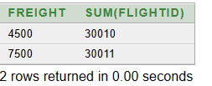

Diaplay last_reading wise total no. of consumers from the billing information table.

select last_reading, sum(cons_id) from billing_master group by last_reading

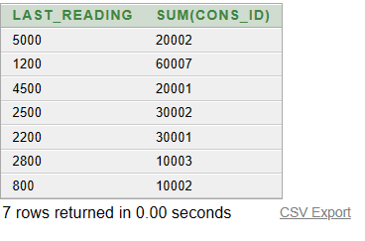

Display journey_date wise total no. of passengers from passenger_details table.

select flight_date , sum(no_of_passengers) from passenger_details group by flight_date

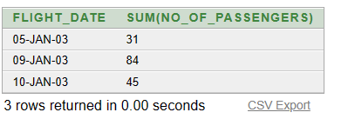

Display flightid wise total no. of passengers from passenger_details table.

select flight_id , sum(no_of_passengers) from passenger_details group by flight_id

